**Trophic interaction models predict interactions across regions, not food web properties**

**Running title:** Interaction models transferability

**Abstract**

**Aim:** Trophic interactions are central to our understanding of essential ecosystem functions as well as their stability. Predicting these interactions has become increasingly common due to the lack of empirical data on trophic interactions for most taxa in most ecosystems. We aim to determine whether and how accurately we can extrapolate to new communities both in terms of pairwise predator-prey interactions and higher level food web attributes (i.e., species position, food web-level properties).

**Location:** Canada, Europe, Tanzania.

**Time period:** Current.

**Major taxa studied:** Terrestrial vertebrates

**Methods:** We use a trait-based model of pairwise trophic interactions, trained independently on four different terrestrial vertebrate food webs (Canadian tundra, Serengeti, alpine south-eastern Pyrenees, and entire Europe) and assess the ability of each instance of the model to predict alternative food webs. We test how well predictions recover individual predator-prey interactions as well as higher level food web properties across geographical locations.

**Results:** We find that, given enough phylogenetic and environmental similarities between food webs, trait-based models predict most interactions and their absence correctly (AUC > 0.82), even across highly contrasting environments. However, network metrics were less well-predicted than single interactions by our models. Predicted food webs were more connected, less modular, and had higher mean trophic levels than observed.

**Main conclusions:** Theory predicts that the variability observed in food webs can be explained by differences in trait distributions and trait-matching relationships. Trait-based models can predict potential interactions amongst species in a region when trained using food web data from reasonably similar region. This suggests that food webs vary spatially primarily through changes in trait distributions. These models, however, are less good at predicting system level food web properties. We thus highlight the need for methodological advances to simultaneously address trophic interactions and the structure of food webs across time and space.

**Key Words:** ecological predictions; food web; model transferability; terrestrial vertebrates; trait matching; trophic interactions

**Introduction**

Ecosystem functions (e.g., energy flows and material cycling) and community stability depend on the trophic relationships that link species within a community (Harvey et al., 2017). Despite the importance of food webs for understanding ecosystem structure and dynamics, recognized over the last 80 years (Lindeman, 1942), we still face major challenges to develop accurate descriptions of natural food webs. The lack of trophic interactions data across most locations and taxa (Poisot et al., 2021) lies at the core of the fundamental technical and practical challenges in food web ecology. Observing interactions is more challenging than observing species because two individuals need to be simultaneously detected while interacting (Jordano, 2016). This challenge is exacerbated by the fact that the number of possible interactions in food webs increases quadratically with the number of species, making the potential set of observations to be made extremely large. Determining all possible interactions among species within a food web is thus difficult even in species-poor ecosystems, which calls for a systematic approach to predict links.

Fortunately, the predator-prey interaction that compose food webs relationships have been shown to respond to a predictable set of neutral and niche processes (Morales-Castilla et al., 2015). A neutral model for trophic interactions suggests that the probability and strength of interactions depend only onto the co-occurrences and abundances of species (Canard et al., 2012). However, recent studies have shown that even if co-occurrence is a requirement for species to interact, it is not evidence for realized trophic interactions (Blanchet et al., 2020). We must thus be careful when making assertions about trophic interactions based solely on co-occurrence data. Niche theory predicts that the matching between the functional traits of predators and those of their prey (e.g., smaller predators eat smaller prey) should improve predictions by identifying interactions that are feasible (Morales-Castilla et al. 2015). Trait-based models have been used to predict food webs in freshwater streams (Pomeranz et al., 2019), marine fishes (Albouy et al., 2014), terrestrial systems comprising vertebrate (Caron et al., 2022; Fricke et al., 2022) and invertebrate species (Laigle et al., 2018), among others. Phylogenetic relationships are also informative since they can serve as proxy for trait relationships, and because interactions and species role (i.e., species positions in the food web) tend to be evolutionary conserved (Gómez et al., 2010; Stouffer et al., 2012).

It is, however, still unclear how well predictive models of trophic interactions can transfer knowledge across different regions. Strydom et al. (2022) recently tested model transferability using a mammal phylogeny to map latent traits extracted from the European mammalian food web to predict its Canadian counterpart. Using this approach, the authors were able to recover 90% of known trophic interactions among Canadian mammals without any prior information on the food web. Thus, this demonstration of model transferability results raise the following question: how inferences would transfer to more contrasting environments?

It is also unclear how well trophic interaction models can predict the underlying structure of entire food webs emerging from individual trophic interactions. Food web structure encompasses system-level properties such as connectivity or number of trophic levels, as well as species traits such as number of prey or their position within the food web. Most studies are aimed at predicting either the properties of food webs (e.g., Williams and Martinez 2008) or their interactions (e.g., Laigle et al. 2018; Pomeranz et al. 2019). They rarely assess how well predicted interactions can recover food web structure. Despite being able to recover most trophic interactions among European tetrapods, Caron et al. (2022) found that food web connectance was systematically overpredicted across Europe by 2-4 times. However, to our knowledge, how well trophic interaction models predict other food web properties (e.g., maximum trophic level, modularity) or species positions (e.g., trophic level, centrality) have never been tested.

Here, we test whether predictive models trained using a network of predator-prey interactions (i.e. a food web) from one geographical region of the world can reliably predict interactions, species role, and food web structure in other regions. Using terrestrial vertebrate food webs from Europe, the Pyrenees, Northern Québec and Labrador, and the Serengeti, we develop trait-based Bayesian hierarchical models to study prediction efficiency of species interactions and food web properties across regions. We aim to (1) identify the factors (i.e., geographic, environmental, functional, or phylogenetic distances) influencing the transferability of models across geographical regions, (2) predict trophic roles across species and (3) quantify the predicted food web properties. First, we expect more similar food webs will yield better transferability since the similarity of the functional relationships driving interactions should depend on the similarity of the environment and species composition of the respective food webs (Gravel et al., 2016). Second, , we expect the prediction of pairwise interactions to be superior to that of food web properties. Some processes constrain food webs properties (e.g., the number of feasible interactions) act at scales different than the processes driving interactions that are encompassed by trophic interaction models (Strydom et al., 2021). This mismatch between the scale of processes modelled and the processes influencing food web properties are likely to create discrepancies between the predicted and observed food webs.

**Methods**

*Food web data*

We extracted predator-prey interactions among terrestrial vertebrates (mammals, birds, amphibians and reptiles) from four well-resolved food webs (Table 1, Figure 1): the European food webs of tetrapods (Maiorano et al., 2020), the Pyrenees vertebrate food webs (Lurgi et al., 2012), the Northern Québec and Labrador food web (Berteaux et al., 2018), and the Serengeti food web (de Visser et al., 2011). All four food webs are compiled from literature review and completed by expert knowledge. The four food webs document the predator-prey interactions between all known terrestrial vertebrates in their respective location. Trophic interaction is a binary variable where 0 defines the absence of predator-prey interaction and 1 the presence of predator-prey interaction between two species. Since each food web document *potential* interactions(i.e., the predator could feed on the prey species), and uses expert knowledge, we assume that they are less sensitive to incomplete sampling than observation-based food webs (i.e., interactions and non-interactions are similarly uncertain). The nodes in the original Serengeti food web are trophic groups including one or more vertebrate species. In this study, we assumed that species within a trophic group share the same predator and prey species. Thus, we can expect more false positives (i.e., non-interactions documented as interactions) in the Serengeti than in the other three food webs. We describe each food web in Appendix S1.

The species composition of the four food webs are different (Table 1). There are no amphibians or reptiles in Northern Québec and Labrador, the Pyrenees food web is dominated by birds (67%) and mammals (23%), with very few reptiles (8%), the European food web has a comparable number of reptiles (21%) and mammals (25%), and almost half (46%) of the Serengeti food web are mammals. The Europe, Pyrenees, and Northern Québec and Labrador food webs all have comparable mean trophic levels (between 1.24 and 1.3) and connectance (between 0.02 and 0.05) compared to the Serengeti food web (mean trophic level: 1.61; connectance: 0.12). Here, the first trophic level (i.e., basal species) are defined as species not feeding on any other terrestrial vertebrates. In Europe, the Pyrenees and Northern Québec and Labrador most species are basal species (e.g., insectivores, herbivores, piscivores), whereas many more species feed on terrestrial vertebrates (non-basal species) in the Serengeti.

*Trait data*

We extracted terrestrial vertebrate species ecological traits from the database compiled by Etard et al. (2020). This dataset combines species-level information from large freely available secondary trait databases (e.g., EltonTraits: Wilman et al. (2014), AmphiBIO: Oliveira et al. (2017)). Overall, the database includes traits for 6 990 amphibian, 11 634 bird, 5 380 mammal, and 10 612 reptile species. We extracted the available body mass (mean: 11 kg; range: 0.001–4 220 kg), longevity (mean: 5 885 days; range: 91–46 386 days), litter or clutch size (mean: 131 offsprings; range: 1–20 000 offsprings), habitat breadth (number of habitats a species uses, using level 2 of the IUCN Habitat Classification Scheme; mean: 10 habitats, range: 1-90 habitats), trophic level (3 levels: herbivore, omnivore, carnivore), activity time (2 categories: nocturnal, non-nocturnal) and habitat use (12 categories: forest, savanna, shrubland, grassland, wetland, rocky areas/cave/subterranean, desert, marine, marine/intertidal or coastal/supratidal, artificial, introduced vegetation) for every species considered in our study.

To match species in the trait databases to the species in the food webs, we standardized their names following the taxonomic backbone of the Global Biodiversity Information Facility (GBIF) using the function *name_backbone* from the package *rgbif* (Chamberlain et al., 2022) in the R statistical language (R Core Team, 2022). In each food web, we excluded species for which no taxonomic information or none of the traits were available. The trait coverage was excellent for each species with more than 80% available traits in any of the food webs (Table 1; Appendix S2). We imputed missing traits with the MissForest algorithm using the *missForest* R package (Stekhoven & Buehlmann, 2012) for amphibians, birds, mammals and reptiles separately. MissForest uses random forests to iteratively predict missing data from the known data. Each random forest uses a different trait as response variable and the remaining traits as predictors.

*Phylogeny data*

We used phylogenetic data to measure how model transferability was influenced by phylogenetic relatedness. We used published global phylogenies for birds (Jetz et al. 2012), amphibians (Jetz and Pyron 2018), squamates (Tonini et al., 2016), turtles (Thomson et al., 2021), and mammals (Upham et al., 2019). All five phylogenies were built from molecular data and delivered as a posterior distribution of trees. We sampled 100 trees from the posterior of each phylogeny and calculated the mean cophenetic distance from these samples between all species of the four food webs. Following Letten & Cornwell (2015), we square root transformed cophenetic distances to better relate with ecological processes like trophic interactions.

*Predictive models*

We trained a Bayesian hierarchical generalized linear model on each of the four food webs (Figure 1a). The response data are trophic interactions we modelled as Bernoulli distributed. Because Caron et al. (2022) found that trait-interaction relationships vary between predator groups, we added varying slope and intercept terms for the taxonomic order of predators. For each model, we randomly drew 30% of the data for validation to keep the prevalence of trophic interaction in the validation subset equal to the prevalence of the entire food web. We used all predator-prey interactions of the remaining 70% of the data and an equal number of absence of interactions for calibration.

,

,

where is the occurrence of interaction between predator *j* and prey *i*, is the associated probability of interaction, and are the fixed intercept and slopes of the linear model, and are the random intercepts and slopes for the order of predator *j*, and are the trait-based predictors.

We used 13 trait-based predictors in the models: five predator traits (trophic level, body mass, habitat breadth, longevity, and clutch size), five prey traits (trophic level, body mass, habitat breadth, longevity, and clutch size), and three trait-match predictors (match in activity time, habitat use and body mass). Since the activity time trait is binary (nocturnal and non-nocturnal) in Etard et al. (2020), activity time match is also a binary variable where a 1 means the predator and the prey share the same activity time trait. Habitat match is the Jaccard similarity index between the habitat used by the prey and the predator across the 12 habitat categories, which takes into account overlap in habitat and specialization to shared habitats. Body mass match is the squared difference between the log-transformed body mass of the prey and the predator, because we expect predators to eat prey within a given body mass interval (small enough to be handled, but large enough to be profitable. We log-transformed body mass, longevity and clutch size, and scaled each continuous predictor (after transformation) by subtracting out the mean and dividing by two times the standard deviation so coefficients of continuous predictors are comparable to unscaled binary predictors (Gelman, 2008).

Fixed effects were drawn from a normal distribution with a mean of 0 and a standard deviation of 1. Random effects were drawn from normal distributions. We used a normal distribution with a mean of 0 and a standard deviation of 1 as prior for the mean and a Half-Cauchy distribution with a scale parameter of 5 as prior for the standard deviation of the random effects:

Model parameters were estimated with Hamiltonian Monte Carlo (Neal, 2011). To fit the models, we ran four chains, each with 2000 warm-up iterations, followed by 2000 iterations for inference. We diagnosed convergence and adequacy with trace rank plots, posterior predictive checks, and we calculated the rank-normalized potential scale reduction factor on split chains for all runs (Vehtari et al. 2021; Appendix S6). We conducted the analyses using Stan (Carpenter et al., 2017) through the package *brms* in R (Bürkner 2017).

*Predicting species interactions*

To quantify model transferability, we used each model to predict the food web on which it was trained and that of the other regions considered (Figure 1a). For each possible predator-prey pair, we extracted the mean of the posterior as the probability of interaction, and the standard deviation of the posterior as the uncertainty around the predicted probability of interaction. When predicting the food web on which the model was trained (i.e., within food web predictions), we compared the predicted interaction probabilities to the validation subset of the food web. When predicting food webs other than the one on which the model was trained (i.e., between food web predictions), we compared the predicted interaction probabilities to the entire empirical food web. We measured performance with the area under the receiver operating characteristic curve (AUC; Hanley and McNeil 1982). AUC varies from 0 to 1 where 0.5 indicates that the model failed to rank interactions higher than absences of interactions (i.e., random predictions), and 1 indicates that the model systematically ranked interactions higher than non-interactions (i.e., perfect predictions). We also measured the area under the precision-recall-gain curve (AUPRG; Flach & Kull, 2015). AUPRG is independent of the true negative rate, making it useful for highly imbalanced datasets, like food webs (many more non-interactions than interactions to predict; Saito & Rehmsmeier, 2015). AUPRG takes a value of 0 for random predictions, and a value of 1 for perfect predictions.

To explore factors influencing model transferability, we assessed the performance of models to predict each food web using three distance measures: geographic distance, environmental dissimilarity, and phylogenetic relatedness. We measured geographic distance as the great-circle distance distance between the polygon centroid delimiting the spatial domain of each food web. Environmental dissimilarity was quantified using all 19 bioclimatic variables in WorldClim (Hijmans, 2021). We extracted the bioclimatic data for all pixels (10’ resolution) falling within the spatial domain of the food webs, and used the mean of each bioclimatic variable to calculate the bioclimatic centroid of each food web. We calculated environmental distance as the Euclidean distance between the food web bioclimatic centroids. To measure phylogenetic relatedness, we used the mean cophenetic distance to the nearest taxon of every species in the predicted food web. We averaged over all species in the predicted food web the cophenetic distance to the phylogenetically closest species in the food web used for calibration. This approach measures the amount of evolutionary history in the predicted food web undocumented by the food web on which the model was trained.

Another test of the factors influencing model transferability focuses on analyzing predictive performance at the species level. For each combination of predicted food web models (i.e., curves in Figure 1b), we measured how accurately the set of prey and predators of each species were predicted also using the AUC. We modelled species-specific performance against how connected the focal species is and how distinct the focal species is to the species pool used to train the predictive model. To do this, we used species normalized degree (number of interactions divided by the maximum possible number of interactions), the functional mean pairwise distance (Mouchet et al., 2010) and distance to nearest taxon (Tucker et al., 2017). Functional mean pairwise distance is the average Gower distance (Gower, 1971) between the focal species and all species in the food web used for calibration. To calculate Gower distances, we used all traits available in Etard (2020) through the function *funct.dist* from the R package mFD (Magneville et al., 2022). Distance to nearest taxon was quantified as the cophenetic distance between the focal species and the closest relative in the species in the food web used for model calibration.

*Predicting species’ functional role*s

Next, we were interested in how well species functional roles were predicted by our models. The functional role of a species is determined by its position in the food web (Cirtwill et al., 2018), which we quantified using five metrics related to the species centrality within the food webs (number of prey, number of predators, betweenness, closeness, eigenvector centrality), two metrics related to their trophic position (trophic levels and omnivory), two module-based metrics (within-module degree and participation coefficient; Guimerà & Amaral, 2005), and the motif profile of each species (Stouffer et al., 2012)*.* We detail each metric, their relation to functional role, and how they were calculated in Appendix S4.

To measure how well species roles were predicted, we compared each species position metric in empirical food webs to the species position in predicted food webs. For predicted food webs, we measured each role metric on 100 samples of the posterior distribution of the entire food web with the mean as the best point estimate for the metric and the standard deviation as measure of uncertainty. For each combination of model, predicted food web, and species role metric, we fitted a linear regression between the predicted position and the empirical position and used the coefficient of determination (R²). We also explored prediction biases (e.g., systematic overestimation/underestimation) using the simple linear models’ coefficients. We expect an intercept of zero for unbiased predictions of species role. An intercept greater than zero would suggest an overall overestimation of the role metric, whereas an intercept less than zero would suggest a systematic underestimation of the role metric. We expect a slope of one for perfect predictions. A slope less than one would suggest that the role values at the lower range are overpredicted, whereas the role values at the upper range are underpredicted (i.e., more homogeneous values across species than in the empirical food web). A slope greater than one would suggest the opposite (i.e., more heterogeneous values across species than in the empirical food web).

*Predicting food web properties*

Finally, we investigated how well the global properties of food webs were predicted. We selected a range of metrics commonly used to quantify food web structure and which have been shown to influence food web functioning and stability: connectance, mean trophic level, maximum trophic level, motifs distribution, food web diameter, number of clusters, and modularity (Borrelli, 2015; Vermaat et al., 2009). As for species position, we evaluated these properties on the empirical food webs and compared them to the properties predicted using the mean of 100 samples of the posterior food web prediction. We detail each metric, their relation to food web function, and how they were calculated in Appendix S4.

*Boosted regression trees*

To make sure results are general and not dependent on the model framework chosen (Bayesian hierarchical generalized linear model), we fitted boosted regression trees (BRT) on each food web and ran the same analyses (Appendix S5). BRT are a machine learning algorithm that allow non-linear relationships between predictors and the response variable (Friedman, 2001). To make results comparable, we used the exact same training/validation splits and same predictor variables to train and measure performance of the BRT and the Bayesian hierarchical generalized linear models.

**Results**

*Predicting trophic interactions*

For all food webs, trophic interactions were better predicted by the model trained on the same food web (within food web predictions) than by models trained on other food webs (between food web predictions; Table 2). For within food web predictions, AUC varied between 0.92 and 0.96 and AUPRG varied between 0.93 and 0.96. Model performance was also good (AUC > 0.82; AUPRG > 0.84) for transfer between the Europe, Pyrenees, and Northern Québec and Labrador food webs, except for the model trained on the Pyrenees predicting Europe. For this case, AUC was good (0.89) but not AUPRG (0.63), suggesting that the model was much better to discriminate non-interactions than interactions. Models did not transfer as well from and to the Serengeti food web, but performance was still good (AUC > 0.75; AUPRG > 0.73). The area under the precision-recall-gain curve, true positive rate, true negative rate, positive predictive value, and negative predictive value were all positively correlated with AUC and showed the same overall pattern (Appendix S6).

To explore the factors influencing the transferability of interaction models, we modelled their performance relative against the geographic, environmental, and phylogenetic distances between the predicted food web and the food web used for training (Figure 2). Overall, performance tended to decrease with environmental (direct effect estimate: -0.29, 95%CrI = [-0.91, 0.33]) and phylogenetic distance (direct effect estimate: -0.31, 95%CrI = [-0.68, 0.05]). Performance also tended to decrease with geographic distance (total effect estimate: -0.57, 95%CrI = [-0.78, -0.35]), but this effect largely disappeared after controlling for phylogenetic and environmental distances (direct effect estimate: -0.24, 95%CrI = [-0.84, 0.36]). Overall, these results suggest that the transferability of our model of trophic interactions decreases with geographic distances, but mainly through the differences in the environmental and phylogenetic domain between the food web predicted and the food web used to train the model.

To identify the factors influencing transferability at the species level, we modelled species-specific performance to the phylogenetic and functional distance between the focal species and the species pool used to train the models (Figure 3). As expected, species with phylogenetically close relatives in the species pool used for calibration were, on average, better predicted than distant relatives (Figure 3a). Species-specific performance slightly decreased at low and intermediate phylogenetic distances, and then dropped significantly at large distances. Models trained and predicted across classes (e.g. mammals to amphibians) had the lowest performance, as expected. This situation only occurs with the Northern Québec and Labrador model predicting the other three food webs as there are no amphibians or reptiles in Northern Québec and Labrador. Surprisingly, predictive performance remained qualitatively unchanged by functional distance (Figure 3b). We also found that interactions of specialist (i.e., species with few interactions) and generalist species (i.e., species with many interactions) were, on average, better predicted than interactions of species of intermediate specialization (Figure 3c).

*Predicting species functional role*

We found significant variation in how well species trophic positions were predicted across models (Figure 4). Species roles were slightly better predicted by within food web predictions than by between food web predictions. Interestingly, some measures of centrality (betweenness and closeness) were not well predicted, whereas others (number of prey and predators, eigenvector centrality) were relatively well predicted.

We also found important biases in the predictions of species roles when we fitted linear regressions between species roles in predicted food webs to their roles in the empirical food webs. The number of prey, predators, trophic level, omnivory, and the frequency of motif positions tended to be similarly overestimated across species (intercept greater than 0). For other measures such as eigenvector centrality, betweenness, closeness, and module-based roles, species had more similar values between predicted and empirical food webs (Appendix S7, slopes less than 1).

*Predicting food web properties*

The majority of food web properties were not well predicted by our interaction models (Figure 5). Connectance, mean and max trophic levels, and the frequency of most motifs were overpredicted, whereas modularity was slightly underpredicted. Mean and variance of relative errors were greater for between- compared to within-food web predictions. In general, predicted food webs were more connected, displayed a higher frequency of most motifs, and were less modular and with less basal species, which increased the trophic level of most species.

*Boosted regression trees*

We found the same general results with BRT (Appendix S5). Overall, BRT performed similarly to our linear model to predict interactions within and across food webs (AUC between ; AUCPR between ). Species functional role and food web properties were be slightly better predicted by the BRT, but we still found similar biases in predictions (Appendix S5).

**Discussion**

Predictive models of trophic interactions have recently become central in filling knowledge gaps about how predator-prey interactions vary across space and time. First, we showed that our trait-based trophic interaction models can predict interactions across regions. We found that, given enough phylogenetic and environmental similarities between the system on which the model is trained and the system for which the predictions are made, models predicted most interactions reasonably well (AUC > 0.82). Our results suggest that, for terrestrial vertebrate food webs, trait relationships driving interactions appear to be relatively general even in highly contrasting environments. Second, although models predicted correctly most interactions, they failed to predict higher-level food web properties. We found systematic biases in the species position and food web properties predictions. Biases varied across metrics, but overall, the predicted food webs were more highly connected, less modular, had more trophic levels, with species within them being more homogeneously connected than their observed counterparts. These higher-level properties of food webs were especially poorly predicted when making between food web predictions (i.e., knowledge transfer). Both these findings do not seem to be specific to Bayesian hierarchical generalized linear models since we found the same overall patterns using boosted regression trees (Appendix S5)

The trait-matching framework of trophic niche theory assumes that variation across food webs arises through differences in the trait-matching rules driving interactions (e.g., body mass relationships between the predator and its prey) and the distribution of traits in different systems (Gravel et al., 2016). Spatial transferability of trait-based models depend on the generality of the trait-matching rules driving interactions. Therefore, our ability to predict food web interactions across contrasting environments suggests that spatial food web variation is mainly driven by changes in the distribution of functional traits, and less so by the variation of trait-matching relationships. These results are in line with previous research finding generalities made on trait-interactions relationships across European bioregions (Caron et al., 2022), the predator-prey body-size ratios within habitat, predator, and prey types (Brose et al., 2006), and the trait-interactions relationships in soil invertebrates across three forest areas in Germany (Laigle et al. 2018). Given that trait-matching rules driving species interactions seem general in reasonably similar environments, it should be possible to use data from well-studied areas to predict interactions in areas we know very little about or forecast (and hindcast) food webs given new trait distributions.

We also highlighted a major limitation of trophic interaction models: trophic interaction models predict interactions, not food webs. Even if most interactions and absences of interactions are well predicted (high true positive and negative rates), there are many more absences of interactions to predict than presences in real food webs (low connectance). This might explain why our models systematically overpredicted the number of interactions (number of prey and predators) across species (Appendix S7). This bias probably propagated through the food webs, explaining why the centrality of species was more evenly distributed, and why the predicted food webs were more connected, less modular, and with higher trophic levels.

ZS

Food webs are more than a collection of independent trophic interactions (Strydom et al., 2021). Some factors constrains food web on their global network properties (e.g., connectance), other the position species occupy within the food web (e.g., trophic level). Here, predicting individual links to predict higher-level properties, suggesting that trophic interactions models cannot capture the constraints acting on the structure of food web. A consequence of such constraints is the spatial and temporal variations of ecological network, which have gained a lot of interest recently (Baiser et al., 2019; Gravel et al., 2019). Area also influences the structural properties of food webs (Galiana et al., 2018). Here, we compared food webs with very different areas (), which could hinder the predictions of food web webs between systems. However, within food-webs predictions produced similarly biased higher-level properties, so area does not seem to be the major constraint explaining model failure to predict realistic networks.

Correcting biases in higher-level property predictions presents an opportunity to improve species interaction predictions. Stacked species distribution models have similar challenges, where models can predict well the distribution of individual species but less higher-level properties of the community (e.g., species richness). Methods have been developed to harness biases in higher-level properties to correct distribution predictions.For example, Leung et al. (2019) combined predicted species distributions and expected species richness to quantify species and spatial biases. They then correlated those biases to species traits and environmental co-variates to improve predicted species distribution. Similar methods that would combine predictions of interactions and networks have the potential to provide better food web predictions. For example, structural food web models can predict the probability distribution of many food web properties (Williams & Martinez, 2008). Information on probable food web structure could be used to correct posterior predictive distributions of species interactions.

Our study suffers from a few limitations that, if overcome, could move us closer to a comprehensive framework for ecological interactions and networks prediction. First, our study relied on terrestrial vertebrates. Although there is no clear *a priori* reason not to be applicable in other systems, our results are unlikely to be general across all taxa and types of interactions. We are not aware of another other test of interaction model transferability, but it would be interesting to investigate if our results hold for systems where trait-matching relationships are stronger or weaker. The exclusion of non-vertebrates (e.g., plants, invertebrates, parasites) also influence the empirical and predicted species role and food web properties. For example, the first trophic levels in our food webs were not primary producers, but species not feeding on terrestrial vertebrates (e.g., herbivores, invertivores). However, extension of trait-matching models to also include invertebrates can be achieved with a coarser resolution (Li et al., 2023) or with additional traits (Laigle et al., 2018). Second, the food webs we used were potential and binary food webs. Trait-matching models predict the probabilities that a species could eat another species given they are encountering each other. Additional data, such as co-occurrence and abundance data, are needed to make predictions of realized and quantitative interactions. Finally, due to the scarcity of food web data, we only had four food webs to work with. This means we only had four sets of within food web predictions, and 12 sets of between food web predictions. This explains the large uncertainty for some of our results (e.g., Figure 2).

Overall, we found that our trait-based interaction models can transfer knowledge relatively well given enough phylogenetic and environmental similarities between systems. They are useful for producing initial expectations even in contrasting ecosystems. This, and other recent research, suggests there are fundamental trait-based constraints on trophic interactions that are generalizable to some extent. The nature of this constraint also appears to result from species traits rather than the ‘match’ between a predator and its prey, which has interesting ties to the broader question of how traits vary between regions and along gradients (Gravel et al., 2016). Future research could better link subfields within trait-based ecology for a comprehensive understanding of how species relate to their environment and to other species, and to enable better predictions of the responses of species and ecosystems to threats and global change.

**References**

Albouy, C., Velez, L., Coll, M., Colloca, F., Loc’h, F. L., Mouillot, D., & Gravel, D. (2014). From projected species distribution to food-web structure under climate change. *Global Change Biology*, *20*(3), 730–741. https://doi.org/10.1111/gcb.12467

Baiser, B., Gravel, D., Cirtwill, A. R., Dunne, J. A., Fahimipour, A. K., Gilarranz, L. J., Grochow, J. A., Li, D., Martinez, N. D., McGrew, A., Poisot, T., Romanuk, T. N., Stouffer, D. B., Trotta, L. B., Valdovinos, F. S., Williams, R. J., Wood, S. A., & Yeakel, J. D. (2019). Ecogeographical rules and the macroecology of food webs. *Global Ecology and Biogeography*, *28*(9), 1204–1218. https://doi.org/10.1111/geb.12925

Berteaux, D., Ropars, P., & Casajus, N. (2018). Toundra Nunavik: Matrice des relations trophiques entre espèces du Labrador et du Québec nordique, v. 1.0 (1980-2010). *Nordicana D36*. https://doi.org/10.5885/45555CE-DA1FF11FA4254703

Blanchet, F. G., Cazelles, K., & Gravel, D. (2020). Co-occurrence is not evidence of ecological interactions. *Ecology Letters*, *23*(7), 1050–1063. https://doi.org/10.1111/ele.13525

Borrelli, J. J. (2015). Selection against instability: Stable subgraphs are most frequent in empirical food webs. *Oikos*, *124*(12), 1583–1588. https://doi.org/10.1111/oik.02176

Brose, U., Jonsson, T., Berlow, E. L., Warren, P., Banasek-Richter, C., Bersier, L.-F., Blanchard, J. L., Brey, T., Carpenter, S. R., Blandenier, M.-F. C., Cushing, L., Dawah, H. A., Dell, T., Edwards, F., Harper-Smith, S., Jacob, U., Ledger, M. E., Martinez, N. D., Memmott, J., … Cohen, J. E. (2006). Consumer–Resource Body-Size Relationships in Natural Food Webs. *Ecology*, *87*(10), 2411–2417. https://doi.org/10.1890/0012-9658(2006)87[2411:CBRINF]2.0.CO;2

Bürkner, P.-C. (2017). **brms**: An *R* Package for Bayesian Multilevel Models Using *Stan*. *Journal of Statistical Software*, *80*(1). https://doi.org/10.18637/jss.v080.i01

Canard, E., Mouquet, N., Marescot, L., Gaston, K. J., Gravel, D., & Mouillot, D. (2012). Emergence of Structural Patterns in Neutral Trophic Networks. *PLOS ONE*, *7*(8), e38295. https://doi.org/10.1371/journal.pone.0038295

Caron, D., Maiorano, L., Thuiller, W., & Pollock, L. J. (2022). Addressing the Eltonian shortfall with trait‐based interaction models. *Ecology Letters*, ele.13966. https://doi.org/10.1111/ele.13966

Carpenter, B., Gelman, A., Hoffman, M. D., Lee, D., Goodrich, B., Betancourt, M., Brubaker, M., Guo, J., Li, P., & Riddell, A. (2017). *Stan*: A Probabilistic Programming Language. *Journal of Statistical Software*, *76*(1). https://doi.org/10.18637/jss.v076.i01

Chamberlain, S., Barve, V., Mcglinn, D., Oldoni, D., Desmet, P., Geffert, L., & Ram, K. (2022). *rgbif: Interface to the global biodiversity information facility API* [Manual]. https://CRAN.R-project.org/package=rgbif

Cirtwill, A. R., Dalla Riva, G. V., Gaiarsa, M. P., Bimler, M. D., Cagua, E. F., Coux, C., & Dehling, D. M. (2018). A review of species role concepts in food webs. *Food Webs*, *16*, e00093. https://doi.org/10.1016/j.fooweb.2018.e00093

Davis, J., & Goadrich, M. (2006). The relationship between Precision-Recall and ROC curves. *Proceedings of the 23rd International Conference on Machine Learning - ICML ’06*, 233–240. https://doi.org/10.1145/1143844.1143874

de Visser, S. N., Freymann, B. P., & Olff, H. (2011). The Serengeti food web: Empirical quantification and analysis of topological changes under increasing human impact. *Journal of Animal Ecology*, *80*(2), 484–494. https://doi.org/10.1111/j.1365-2656.2010.01787.x

Duffy, J. E., Cardinale, B. J., France, K. E., McIntyre, P. B., Thébault, E., & Loreau, M. (2007). The functional role of biodiversity in ecosystems: Incorporating trophic complexity. *Ecology Letters*, *10*(6), 522–538. https://doi.org/10.1111/j.1461-0248.2007.01037.x

Estes, J. A., Terborgh, J., Brashares, J. S., Power, M. E., Berger, J., Bond, W. J., Carpenter, S. R., Essington, T. E., Holt, R. D., Jackson, J. B. C., Marquis, R. J., Oksanen, L., Oksanen, T., Paine, R. T., Pikitch, E. K., Ripple, W. J., Sandin, S. A., Scheffer, M., Schoener, T. W., … Wardle, D. A. (2011). Trophic Downgrading of Planet Earth. *Science*, *333*(6040), 301–306. https://doi.org/10.1126/science.1205106

Etard, A., Morrill, S., & Newbold, T. (2020). Global gaps in trait data for terrestrial vertebrates. *Global Ecology and Biogeography*, *29*(12), 2143–2158. https://doi.org/10.1111/geb.13184

Flach, P., & Kull, M. (2015). Precision-Recall-Gain Curves: PR Analysis Done Right. In C. Cortes, N. Lawrence, D. Lee, M. Sugiyama, & R. Garnett (Eds.), *Advances in Neural Information Processing Systems* (Vol. 28). Curran Associates, Inc. https://proceedings.neurips.cc/paper_files/paper/2015/file/33e8075e9970de0cfea955afd4644bb2-Paper.pdf

Fricke, E. C., Hsieh, C., Middleton, O., Gorczynski, D., Cappello, C. D., Sanisidro, O., Rowan, J., Svenning, J.-C., & Beaudrot, L. (2022). Collapse of terrestrial mammal food webs since the Late Pleistocene. *Science*, *377*(6609), 1008–1011. https://doi.org/10.1126/science.abn4012

Friedman, J. H. (2001). Greedy Function Approximation: A Gradient Boosting Machine. *The Annals of Statistics*, *29*(5), 1189–1232. JSTOR.

Galiana, N., Lurgi, M., Claramunt-López, B., Fortin, M.-J., Leroux, S., Cazelles, K., Gravel, D., & Montoya, J. M. (2018). The spatial scaling of species interaction networks. *Nature Ecology & Evolution*, *2*(5), Article 5. https://doi.org/10.1038/s41559-018-0517-3

Gelman, A. (2008). Scaling regression inputs by dividing by two standard deviations. *Statistics in Medicine*, *27*(15), 2865–2873. https://doi.org/10.1002/sim.3107

Gómez, J. M., Verdú, M., & Perfectti, F. (2010). Ecological interactions are evolutionarily conserved across the entire tree of life. *Nature*, *465*(7300), Article 7300. https://doi.org/10.1038/nature09113

Gower, J. C. (1971). A General Coefficient of Similarity and Some of Its Properties. *Biometrics*, *27*(4), 857–871. https://doi.org/10.2307/2528823

Gravel, D., Albouy, C., & Thuiller, W. (2016). The meaning of functional trait composition of food webs for ecosystem functioning. *Philosophical Transactions of the Royal Society B: Biological Sciences*, *371*(1694), 20150268. https://doi.org/10.1098/rstb.2015.0268

Gravel, D., Baiser, B., Dunne, J. A., Kopelke, J.-P., Martinez, N. D., Nyman, T., Poisot, T., Stouffer, D. B., Tylianakis, J. M., Wood, S. A., & Roslin, T. (2019). Bringing Elton and Grinnell together: A quantitative framework to represent the biogeography of ecological interaction networks. *Ecography*, *42*(3), 401–415. https://doi.org/10.1111/ecog.04006

Guimerà, R., & Amaral, L. A. N. (2005). Cartography of complex networks: Modules and universal roles. *Journal of Statistical Mechanics: Theory and Experiment*, *2005*(02), P02001. https://doi.org/10.1088/1742-5468/2005/02/P02001

Hanley, J. A., & McNeil, B. J. (1982). The meaning and use of the area under a receiver operating characteristic (ROC) curve. *Radiology*, *143*(1), 29–36. https://doi.org/10.1148/radiology.143.1.7063747

Harvey, E., Gounand, I., Ward, C. L., & Altermatt, F. (2017). Bridging ecology and conservation: From ecological networks to ecosystem function. *Journal of Applied Ecology*, *54*(2), 371–379. https://doi.org/10.1111/1365-2664.12769

Hijmans, R. J. (2021). *raster: Geographic data analysis and modeling* [Manual]. https://CRAN.R-project.org/package=raster

Jetz, W., & Pyron, R. A. (2018). The interplay of past diversification and evolutionary isolation with present imperilment across the amphibian tree of life. *Nature Ecology & Evolution*, *2*(5), Article 5. https://doi.org/10.1038/s41559-018-0515-5

Jetz, W., Thomas, G. H., Joy, J. B., Hartmann, K., & Mooers, A. O. (2012). The global diversity of birds in space and time. *Nature*, *491*(7424), Article 7424. https://doi.org/10.1038/nature11631

Jordano, P. (2016). Sampling networks of ecological interactions. *Functional Ecology*, *30*(12), 1883–1893. https://doi.org/10.1111/1365-2435.12763

Laigle, I., Aubin, I., Digel, C., Brose, U., Boulangeat, I., & Gravel, D. (2018). Species traits as drivers of food web structure. *Oikos*, *127*(2), 316–326. https://doi.org/10.1111/oik.04712

Letten, A. D., & Cornwell, W. K. (2015). Trees, branches and (square) roots: Why evolutionary relatedness is not linearly related to functional distance. *Methods in Ecology and Evolution*, *6*(4), 439–444. https://doi.org/10.1111/2041-210X.12237

Leung, B., Hudgins, E. J., Potapova, A., & Ruiz-Jaen, M. C. (2019). A new baseline for countrywide α-diversity and species distributions: Illustration using >6,000 plant species in Panama. *Ecological Applications*, *29*(3), e01866. https://doi.org/10.1002/eap.1866

Li, J., Luo, M., Wang, S., Gauzens, B., Hirt, M. R., Rosenbaum, B., & Brose, U. (2023). A size-constrained feeding-niche model distinguishes predation patterns between aquatic and terrestrial food webs. *Ecology Letters*, *26*(1), 76–86. https://doi.org/10.1111/ele.14134

Lindeman, R. L. (1942). The Trophic-Dynamic Aspect of Ecology. *Ecology*, *23*(4), 399–417. https://doi.org/10.2307/1930126

Lurgi, M., Galiana, N., López, B. C., Joppa, L. N., & Montoya, J. M. (2014). Network complexity and species traits mediate the effects of biological invasions on dynamic food webs. *Frontiers in Ecology and Evolution*, *2*. https://www.frontiersin.org/articles/10.3389/fevo.2014.00036

Lurgi, M., López, B. C., & Montoya, J. M. (2012). Climate change impacts on body size and food web structure on mountain ecosystems. *Philosophical Transactions of the Royal Society B: Biological Sciences*, *367*(1605), 3050–3057. https://doi.org/10.1098/rstb.2012.0239

Magneville, C., Loiseau, N., Albouy, C., Casajus, N., Claverie, T., Escalas, A., Leprieur, F., Maire, E., Mouillot, D., & Villéger, S. (2022). mFD: An R package to compute and illustrate the multiple facets of functional diversity. *Ecography*, *2022*(1). https://doi.org/10.1111/ecog.05904

Maiorano, L., Montemaggiori, A., Ficetola, G. F., O’Connor, L., & Thuiller, W. (2020). TETRA‐EU 1.0: A species‐level trophic metaweb of European tetrapods. *Global Ecology and Biogeography*, geb.13138. https://doi.org/10.1111/geb.13138

Morales-Castilla, I., Matias, M. G., Gravel, D., & Araújo, M. B. (2015). Inferring biotic interactions from proxies. *Trends in Ecology & Evolution*, *30*(6), 347–356. https://doi.org/10.1016/j.tree.2015.03.014

Mouchet, M. A., Villéger, S., Mason, N. W. H., & Mouillot, D. (2010). Functional diversity measures: An overview of their redundancy and their ability to discriminate community assembly rules. *Functional Ecology*, *24*(4), 867–876. https://doi.org/10.1111/j.1365-2435.2010.01695.x

Neal, R. M. (2011). MCMC Using Hamiltonian Dynamics. In *Handbook of Markov Chain Monte Carlo* (pp. 113–162). CRC Press. https://doi.org/10.1201/b10905-7

Oliveira, B. F., São-Pedro, V. A., Santos-Barrera, G., Penone, C., & Costa, G. C. (2017). AmphiBIO, a global database for amphibian ecological traits. *Scientific Data*, *4*(1), Article 1. https://doi.org/10.1038/sdata.2017.123

Poisot, T., Bergeron, G., Cazelles, K., Dallas, T., Gravel, D., MacDonald, A., Mercier, B., Violet, C., Vissault, S., & Chapman, D. (2021). Global knowledge gaps in species interaction networks data. *Journal of Biogeography*, jbi.14127. https://doi.org/10.1111/jbi.14127

Pomeranz, J. P. F., Thompson, R. M., Poisot, T., & Harding, J. S. (2019). Inferring predator–prey interactions in food webs. *Methods in Ecology and Evolution*, *10*(3), 356–367. https://doi.org/10.1111/2041-210X.13125

R Core Team. (2022). *R: A Language and Environment for Statistical Computing*. R Foundation for Statistical Computing. https://www.R-project.org/

Saito, T., & Rehmsmeier, M. (2015). The Precision-Recall Plot Is More Informative than the ROC Plot When Evaluating Binary Classifiers on Imbalanced Datasets. *PLOS ONE*, *10*(3), e0118432. https://doi.org/10.1371/journal.pone.0118432

Stekhoven, D. J., & Buehlmann, P. (2012). MissForest—Non-parametric missing value imputation for mixed-type data. *Bioinformatics (Oxford, England)*, *28*(1), 112–118.

Stouffer, D. B., Sales-Pardo, M., Sirer, M. I., & Bascompte, J. (2012). Evolutionary Conservation of Species’ Roles in Food Webs. *Science*, *335*(6075), 1489–1492. https://doi.org/10.1126/science.1216556

Strydom, T., Bouskila, S., Banville, F., Barros, C., Caron, D., Farrell, M. J., Fortin, M.-J., Hemming, V., Mercier, B., Pollock, L. J., Runghen, R., Dalla Riva, G. V., & Poisot, T. (2022). Food web reconstruction through phylogenetic transfer of low-rank network representation. *Methods in Ecology and Evolution*, *13*(12), 2838–2849. https://doi.org/10.1111/2041-210X.13835

Strydom, T., Catchen, M. D., Banville, F., Caron, D., Dansereau, G., Desjardins-Proulx, P., Forero-Muñoz, N. R., Higino, G., Mercier, B., Gonzalez, A., Gravel, D., Pollock, L., & Poisot, T. (2021). A roadmap towards predicting species interaction networks (across space and time). *Philosophical Transactions of the Royal Society of London. Series B, Biological Sciences*, *376*(1837), 20210063. https://doi.org/10.1098/rstb.2021.0063

Thomson, R. C., Spinks, P. Q., & Shaffer, H. B. (2021). A global phylogeny of turtles reveals a burst of climate-associated diversification on continental margins. *Proceedings of the National Academy of Sciences*, *118*(7), e2012215118. https://doi.org/10.1073/pnas.2012215118

Tonini, J. F. R., Beard, K. H., Ferreira, R. B., Jetz, W., & Pyron, R. A. (2016). Fully-sampled phylogenies of squamates reveal evolutionary patterns in threat status. *Biological Conservation*, *204*, 23–31. https://doi.org/10.1016/j.biocon.2016.03.039

Tucker, C. M., Cadotte, M. W., Carvalho, S. B., Davies, T. J., Ferrier, S., Fritz, S. A., Grenyer, R., Helmus, M. R., Jin, L. S., Mooers, A. O., Pavoine, S., Purschke, O., Redding, D. W., Rosauer, D. F., Winter, M., & Mazel, F. (2017). A guide to phylogenetic metrics for conservation, community ecology and macroecology. *Biological Reviews*, *92*(2), 698–715. https://doi.org/10.1111/brv.12252

Upham, N. S., Esselstyn, J. A., & Jetz, W. (2019). Inferring the mammal tree: Species-level sets of phylogenies for questions in ecology, evolution, and conservation. *PLOS Biology*, *17*(12), e3000494. https://doi.org/10.1371/journal.pbio.3000494

Vehtari, A., Gelman, A., Simpson, D., Carpenter, B., & Bürkner, P.-C. (2021). Rank-Normalization, Folding, and Localization: An Improved Rˆ for Assessing Convergence of MCMC (with Discussion). *Bayesian Analysis*, *16*(2), 667–718. https://doi.org/10.1214/20-BA1221

Vermaat, J. E., Dunne, J. A., & Gilbert, A. J. (2009). Major dimensions in food-web structure properties. *Ecology*, *90*(1), 278–282. https://doi.org/10.1890/07-0978.1

Wang, S., & Brose, U. (2018). Biodiversity and ecosystem functioning in food webs: The vertical diversity hypothesis. *Ecology Letters*, *21*(1), 9–20. https://doi.org/10.1111/ele.12865

Williams, R. J., & Martinez, N. D. (2008). Success and Its Limits among Structural Models of Complex Food Webs. *Journal of Animal Ecology*, *77*(3), 512–519.

Wilman, H., Belmaker, J., Simpson, J., Rosa, C. de la, Rivadeneira, M. M., & Jetz, W. (2014). EltonTraits 1.0: Species-level foraging attributes of the world’s birds and mammals. *Ecology*, *95*(7), 2027–2027. https://doi.org/10.1890/13-1917.1

**Data Accessibility Statement**

All data sources have been previously published. All data used in the analyses and relevant code will be archived on a Open Science Framework repository.

Table 1: *Summary statistics of the food webs used in this study after excluding species for which no match was found in the GBIF Backbone Taxonomy or was not documented in the trait database. Trait coverage is the percentage of traits documented in Etard et al. (2020) before imputing missing traits.*

**

Table 2: Food webs are better predicted by their own trained model. Area under the receiver operating curve (AUC) and area under the precision-recall-gain curve (AUPRG) of each model predicting every food web.



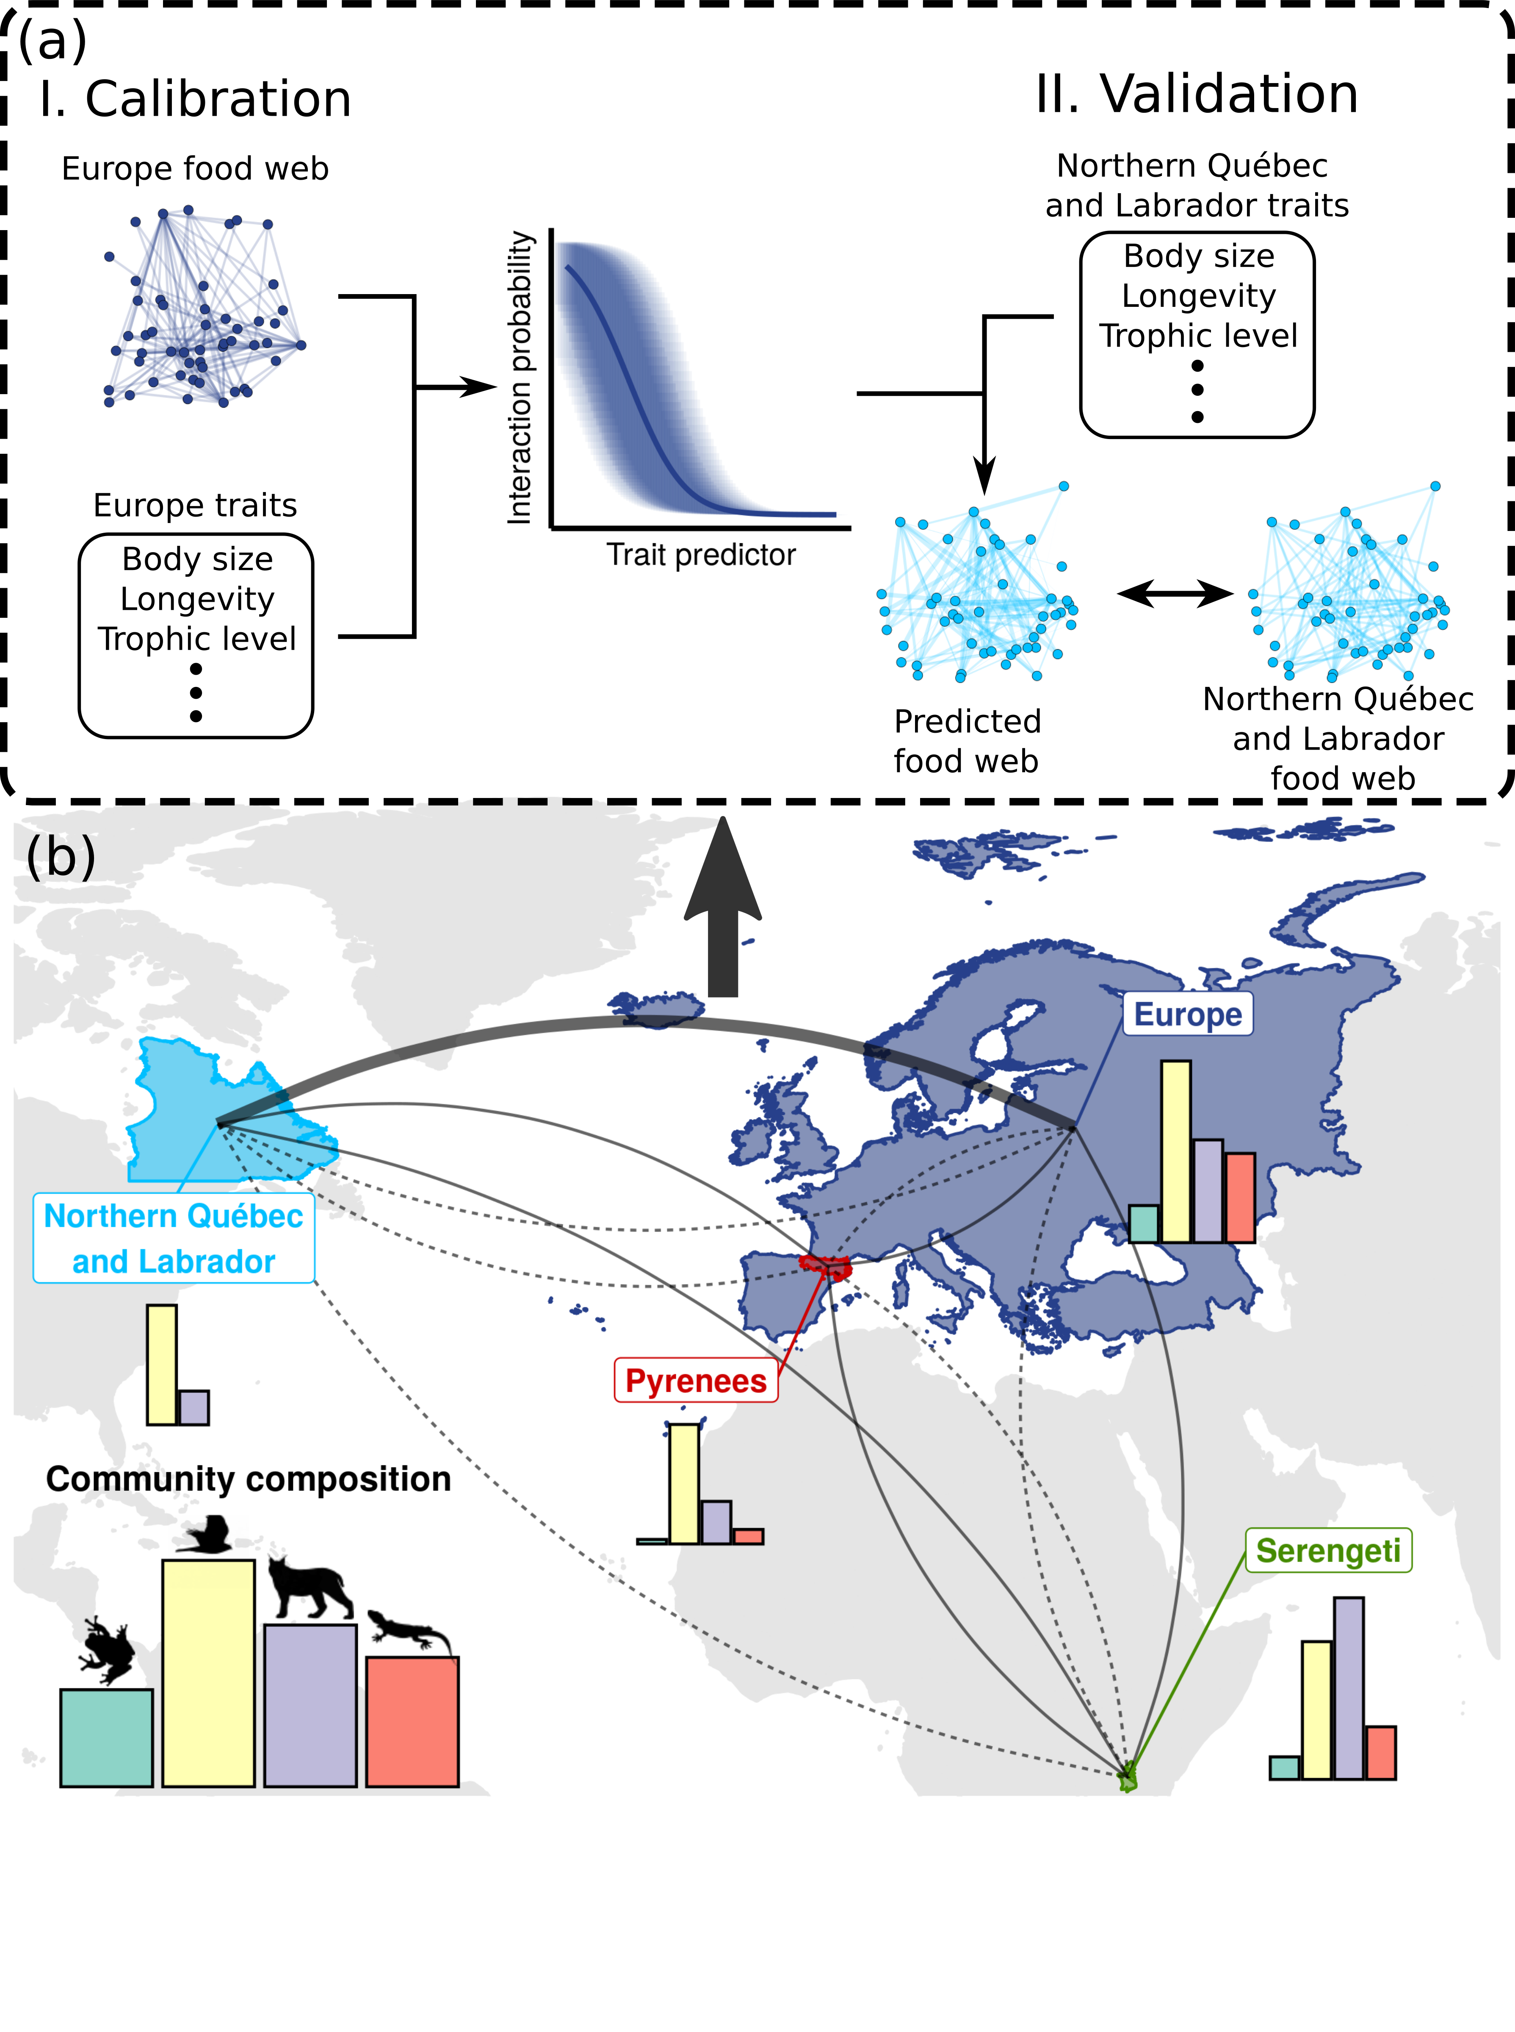  
Figure 1: **Trophic interactions model transferability analysis workflow.** We trained a trophic interaction model using each food web considered in this study (panel a.I). We measured the performance of the four models on a validation subset for within food web predictions, and the entire food webs for between food web predictions (panel a.II). Panel (a) shows an example workflow for between food web predictions. Panel (b) maps the spatial domain of each food web. The 12 curves are the model-food web pairs for between food web predictions. The within food web predictions are not shown in the figure. Bar plots are the proportion of amphibians (green), birds (yellow), mammals (purple), and reptiles (red) in each food web.

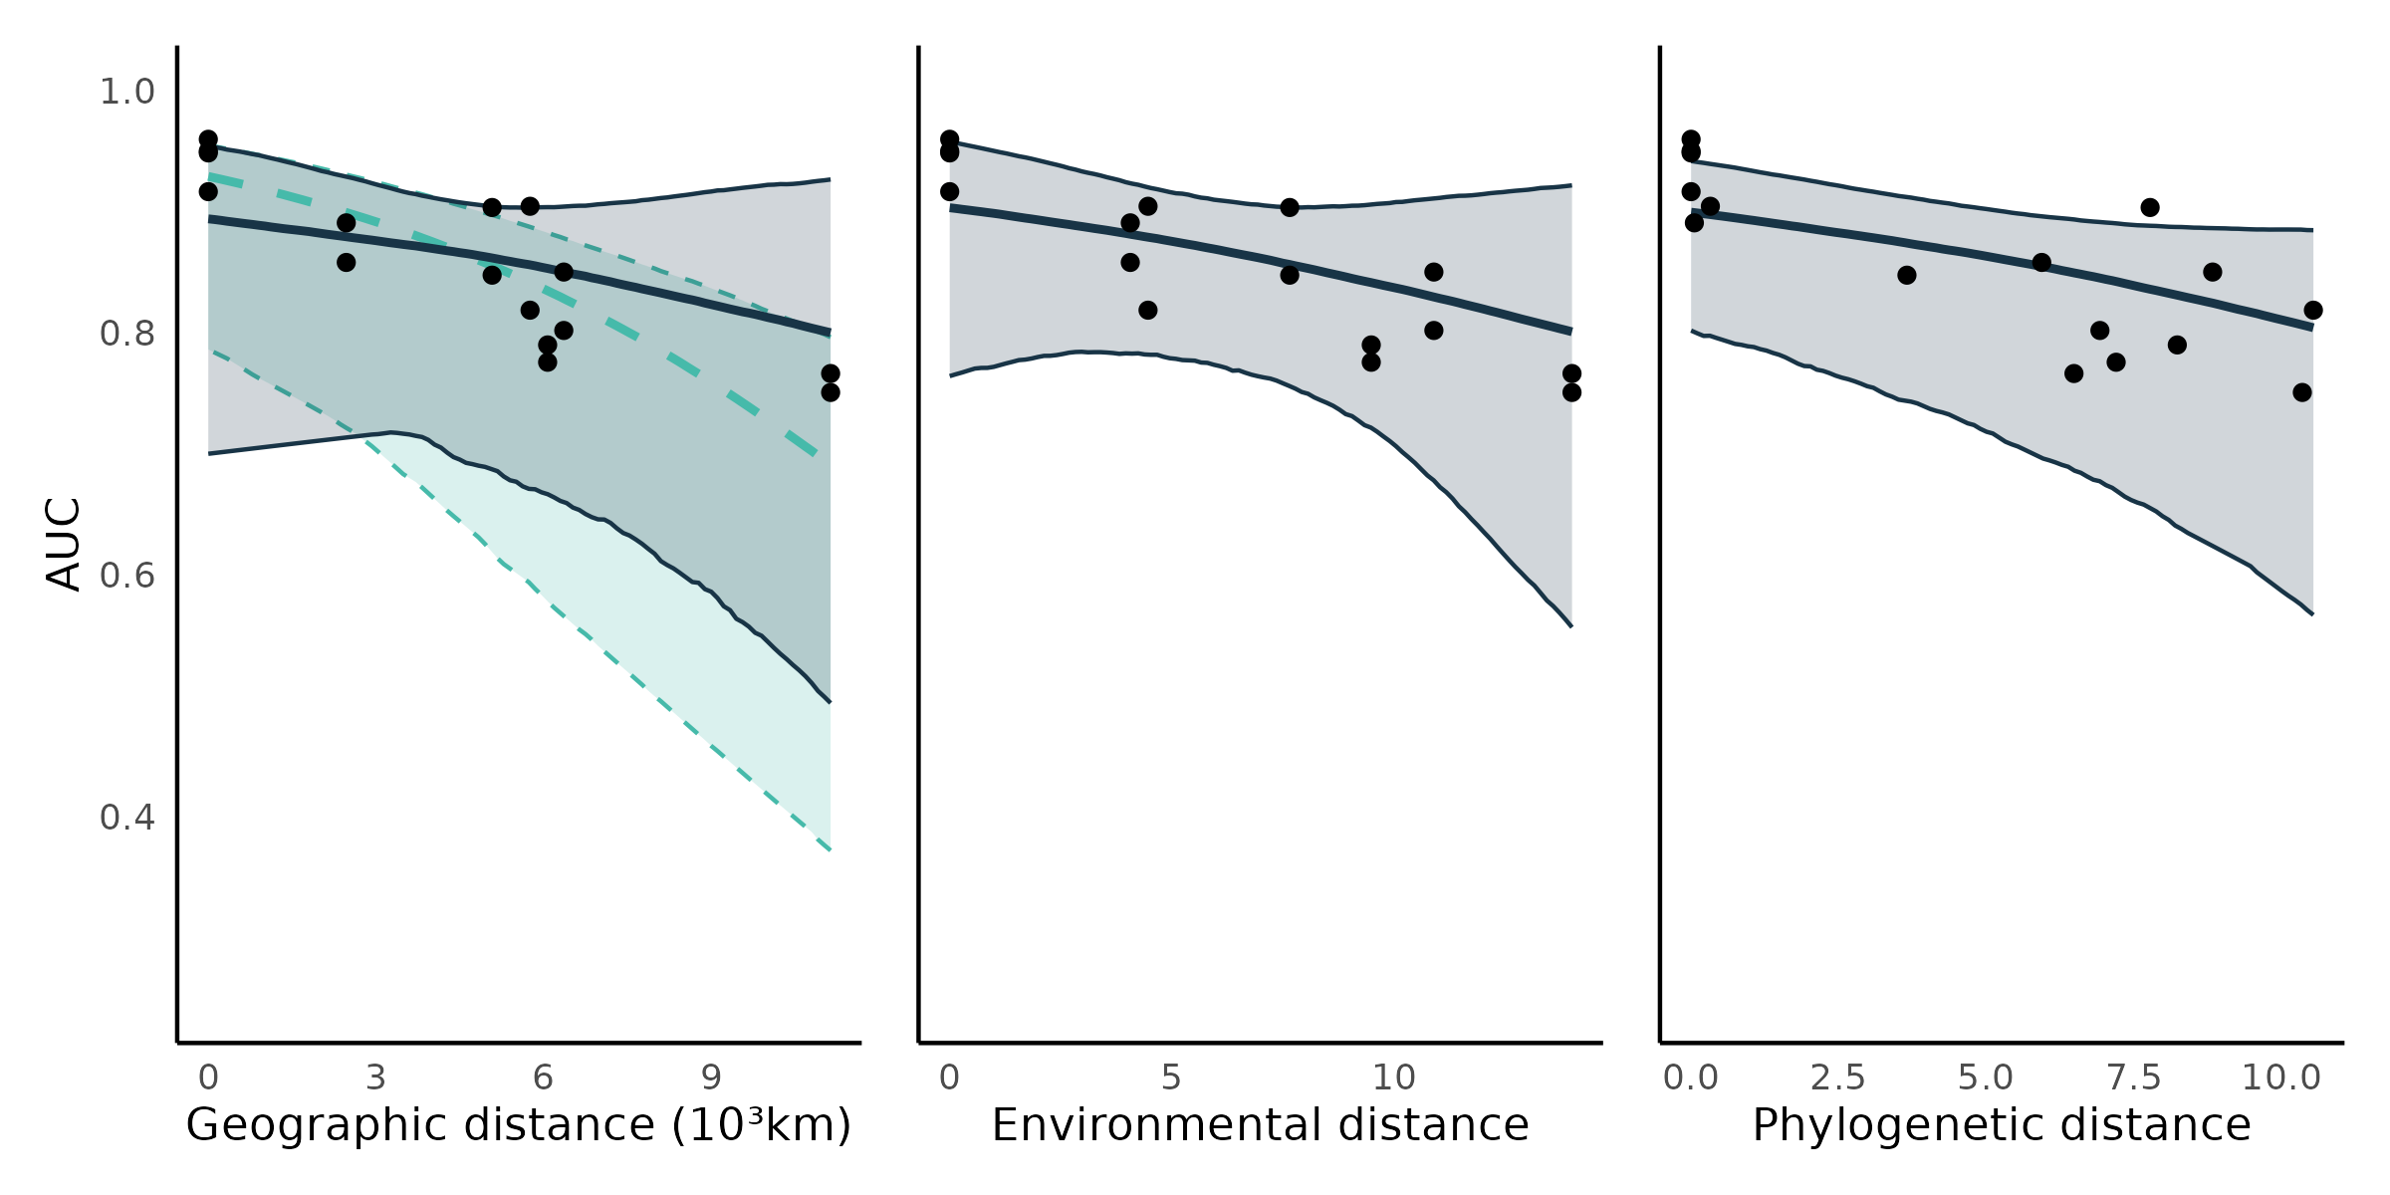Figure 2: **Transferability of predictive models.** Each point is the predictive performance (AUC) of a model-food web predicted combination (16 combination;Table 2). The trend lines are the median effects with their 95% credible interval constructed with the posterior predictive distribution of geographic, environmental, and phylogenetic distances on predictive performance. Shown are the total (includes the indirect effects of environmental and phylogenetic distances; turquoise) and partial (controls for environmental and phylogenetic distances; dark blue) effects of geographic distance , and the direct (controlling for geographic distance) effects of environmental and phylogenetic distances.

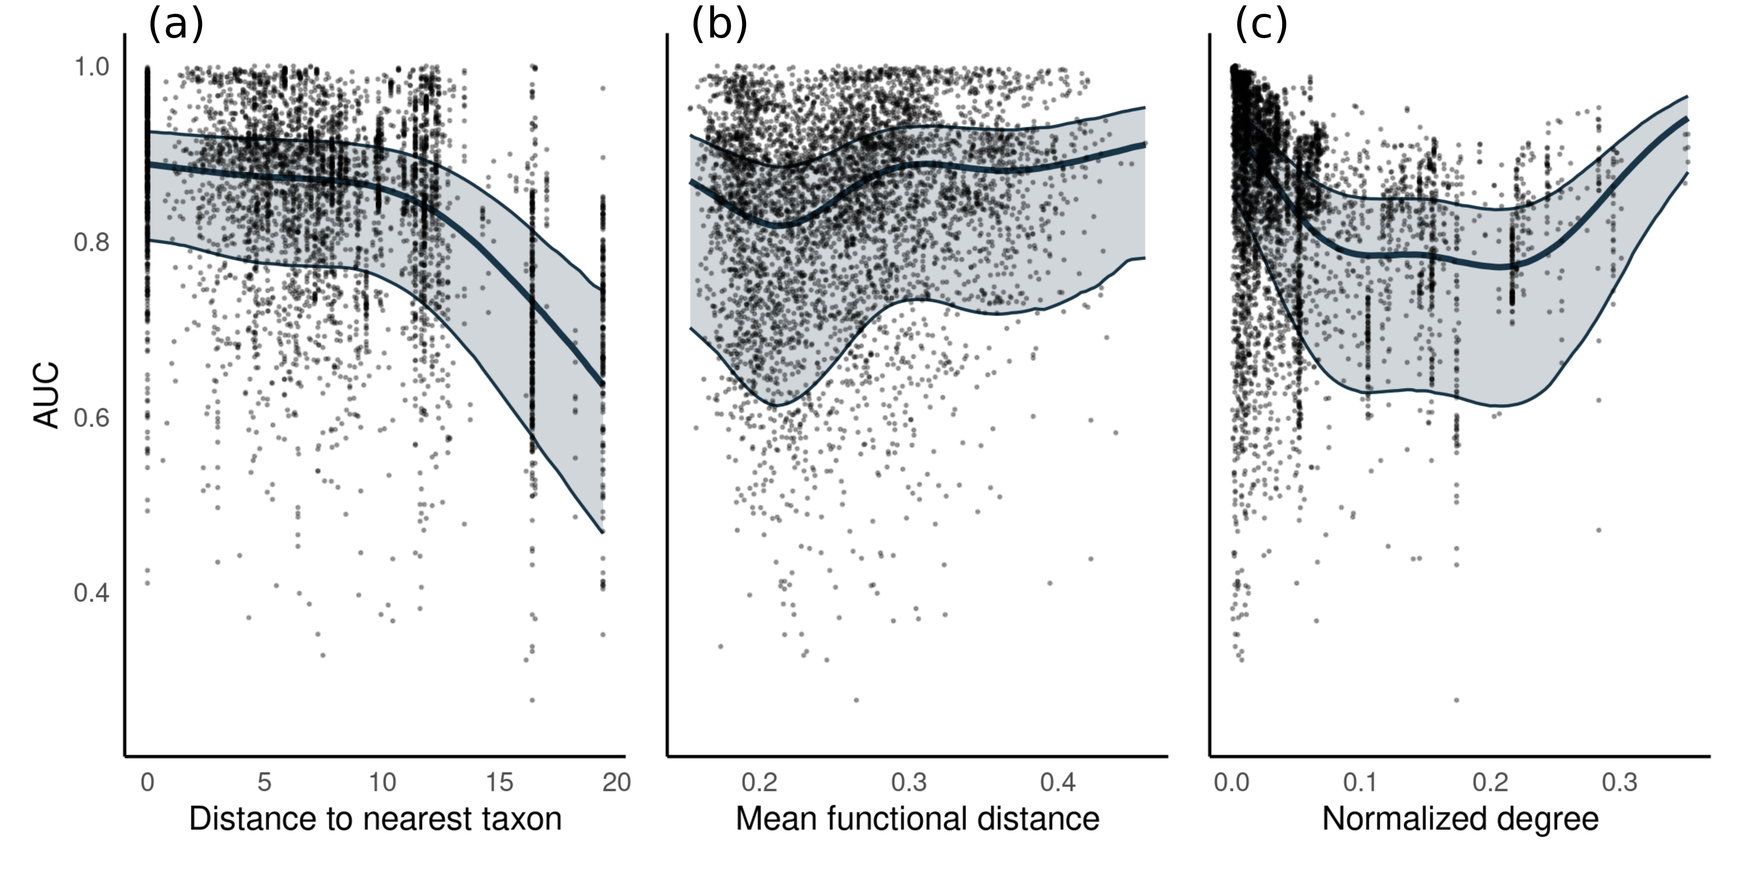  
Figure *3*: ***Predicting species interactions****. Performance of the models to predict the interactions of species in the alternative food webs. Each point is the performance to predict the prey and predators of a single species. The trend lines are the median effects with their 95% credible interval constructed from the posterior predictive distribution of (a) distance to the nearest taxon, (b) mean functional pairwise distance, and (c) normalized degree on predictive performance.*

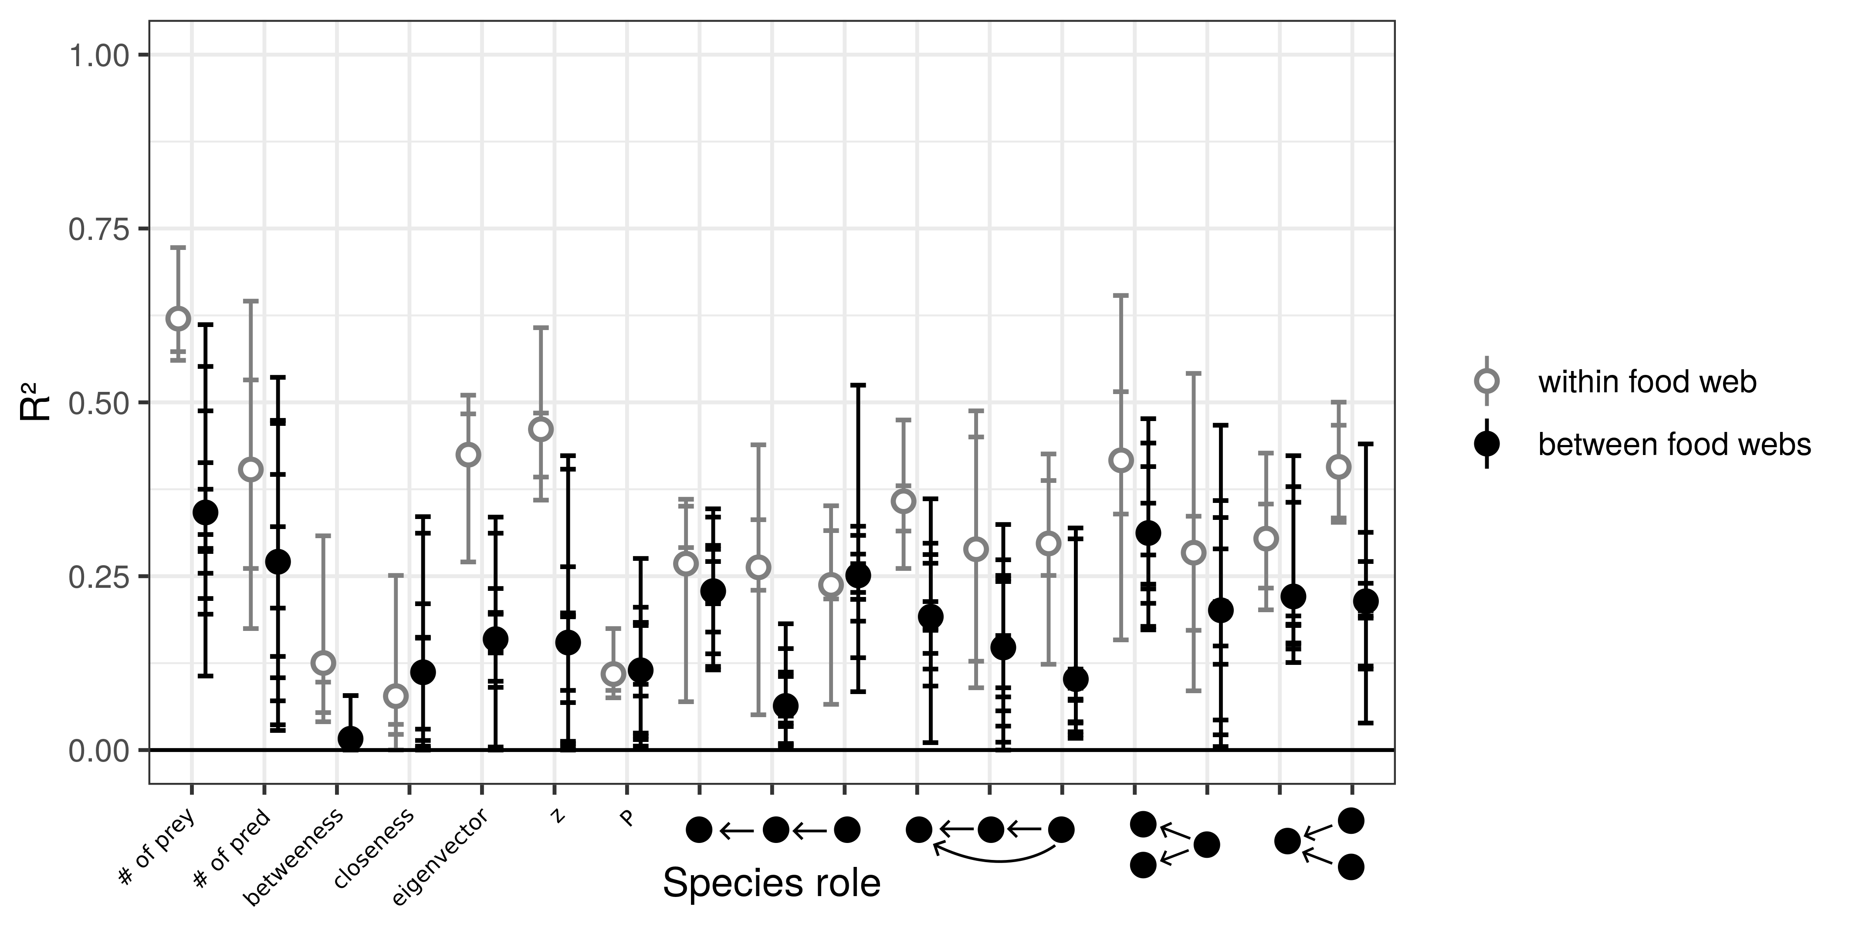  
Figure 4: ***Predicting species functional role****. Performance of models to predict species functional role measured as the proportion of the variance in trophic positions explained by the models (R²). From left to right, the figure shows the number of prey, number of predators, betweenness, closeness, eigenvector centrality, within-module degree (z), participation coefficient (P), times the species is at a specific position in the linear chain (predator – consumer - resource), intraguild predation (omnivore – consumer - resource), direct competition (2 consumers – 1 resource), and apparent competition motifs (1 consumer – 2 resources). The short horizontal lines are the R² for each role, model, and food web predicted combination. Grey open dots are the mean R² for within food web predictions. Full black dots are the mean R² for between food web predictions.*

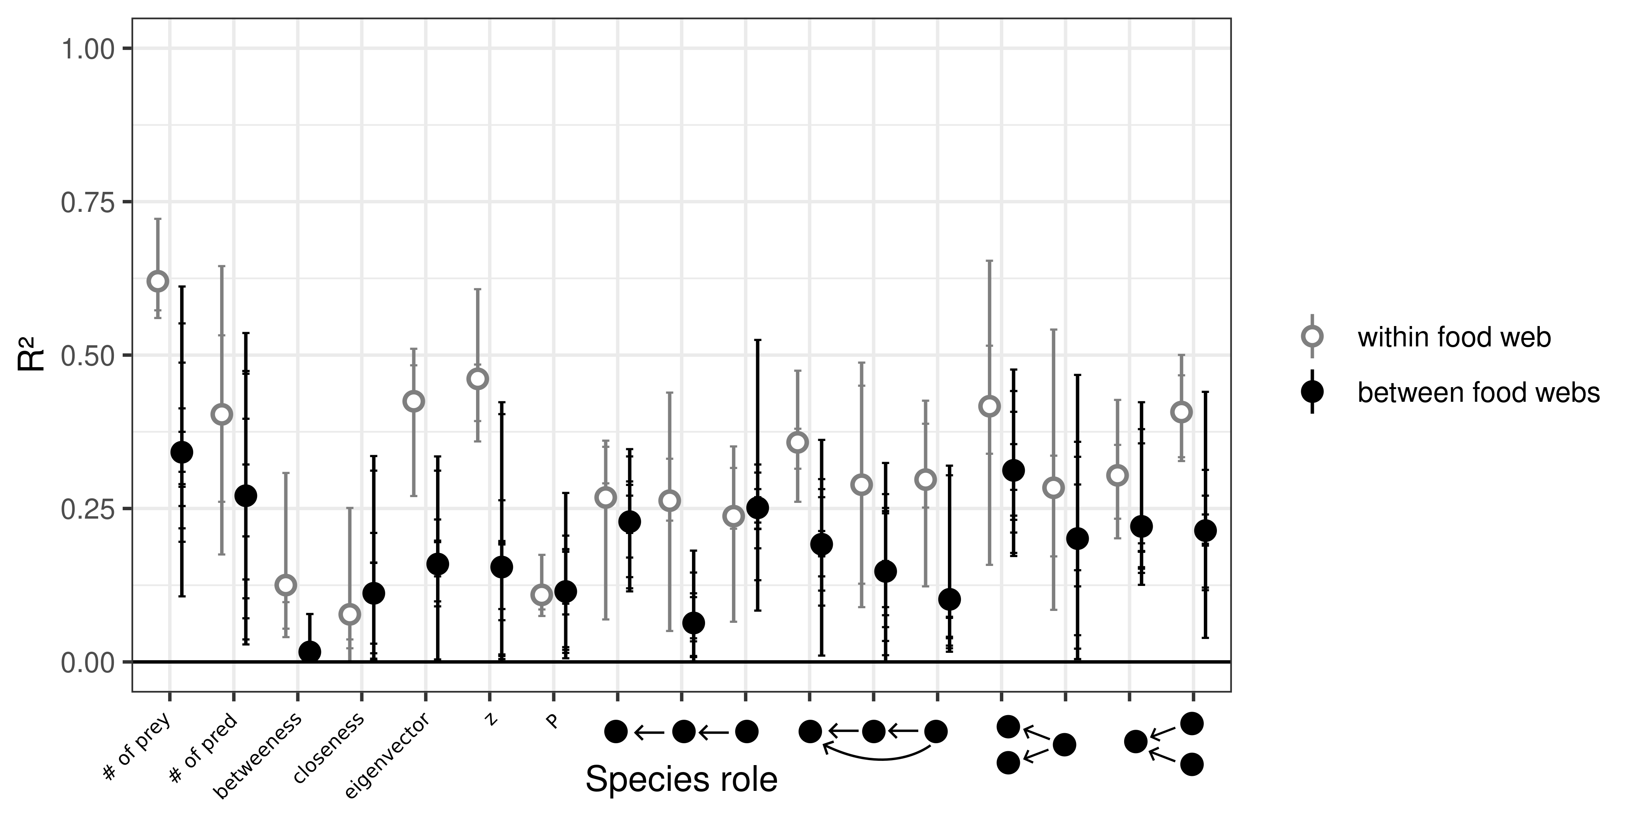  
Figure 4: ***Predicting species functional role****. Performance of models to predict species functional role measured as the proportion of the variance in trophic positions explained by the models (R²). From left to right, the figure shows the number of prey, number of predators, betweenness, closeness, eigenvector centrality, within-module degree (z), participation coefficient (P), times the species is at a specific position in the linear chain (predator – consumer - resource), intraguild predation (omnivore – consumer - resource), direct competition (2 consumers – 1 resource), and apparent competition motifs (1 consumer – 2 resources). The short horizontal lines are the R² for each role, model, and food web predicted combination. Grey open dots are the mean R² with for within food web predictions. Full black dots are the mean R² for across food web predictions.*

  
Figure 4: ***Predicting species functional role****. Performance of models to predict species functional role measured as the proportion of the variance in trophic positions explained by the models (R²). From left to right, the figure shows the number of prey, number of predators, betweenness, closeness, eigenvector centrality, within-module degree (z), participation coefficient (P), times the species is at a specific position in the linear chain (predator – consumer - resource), intraguild predation (omnivore – consumer - resource), direct competition (2 consumers – 1 resource), and apparent competition motifs (1 consumer – 2 resources). The short horizontal lines are the R² for each role, model, and food web predicted combination. Grey open dots are the mean R² with for within food web predictions. Full black dots are the mean R² for across food web predictions.*

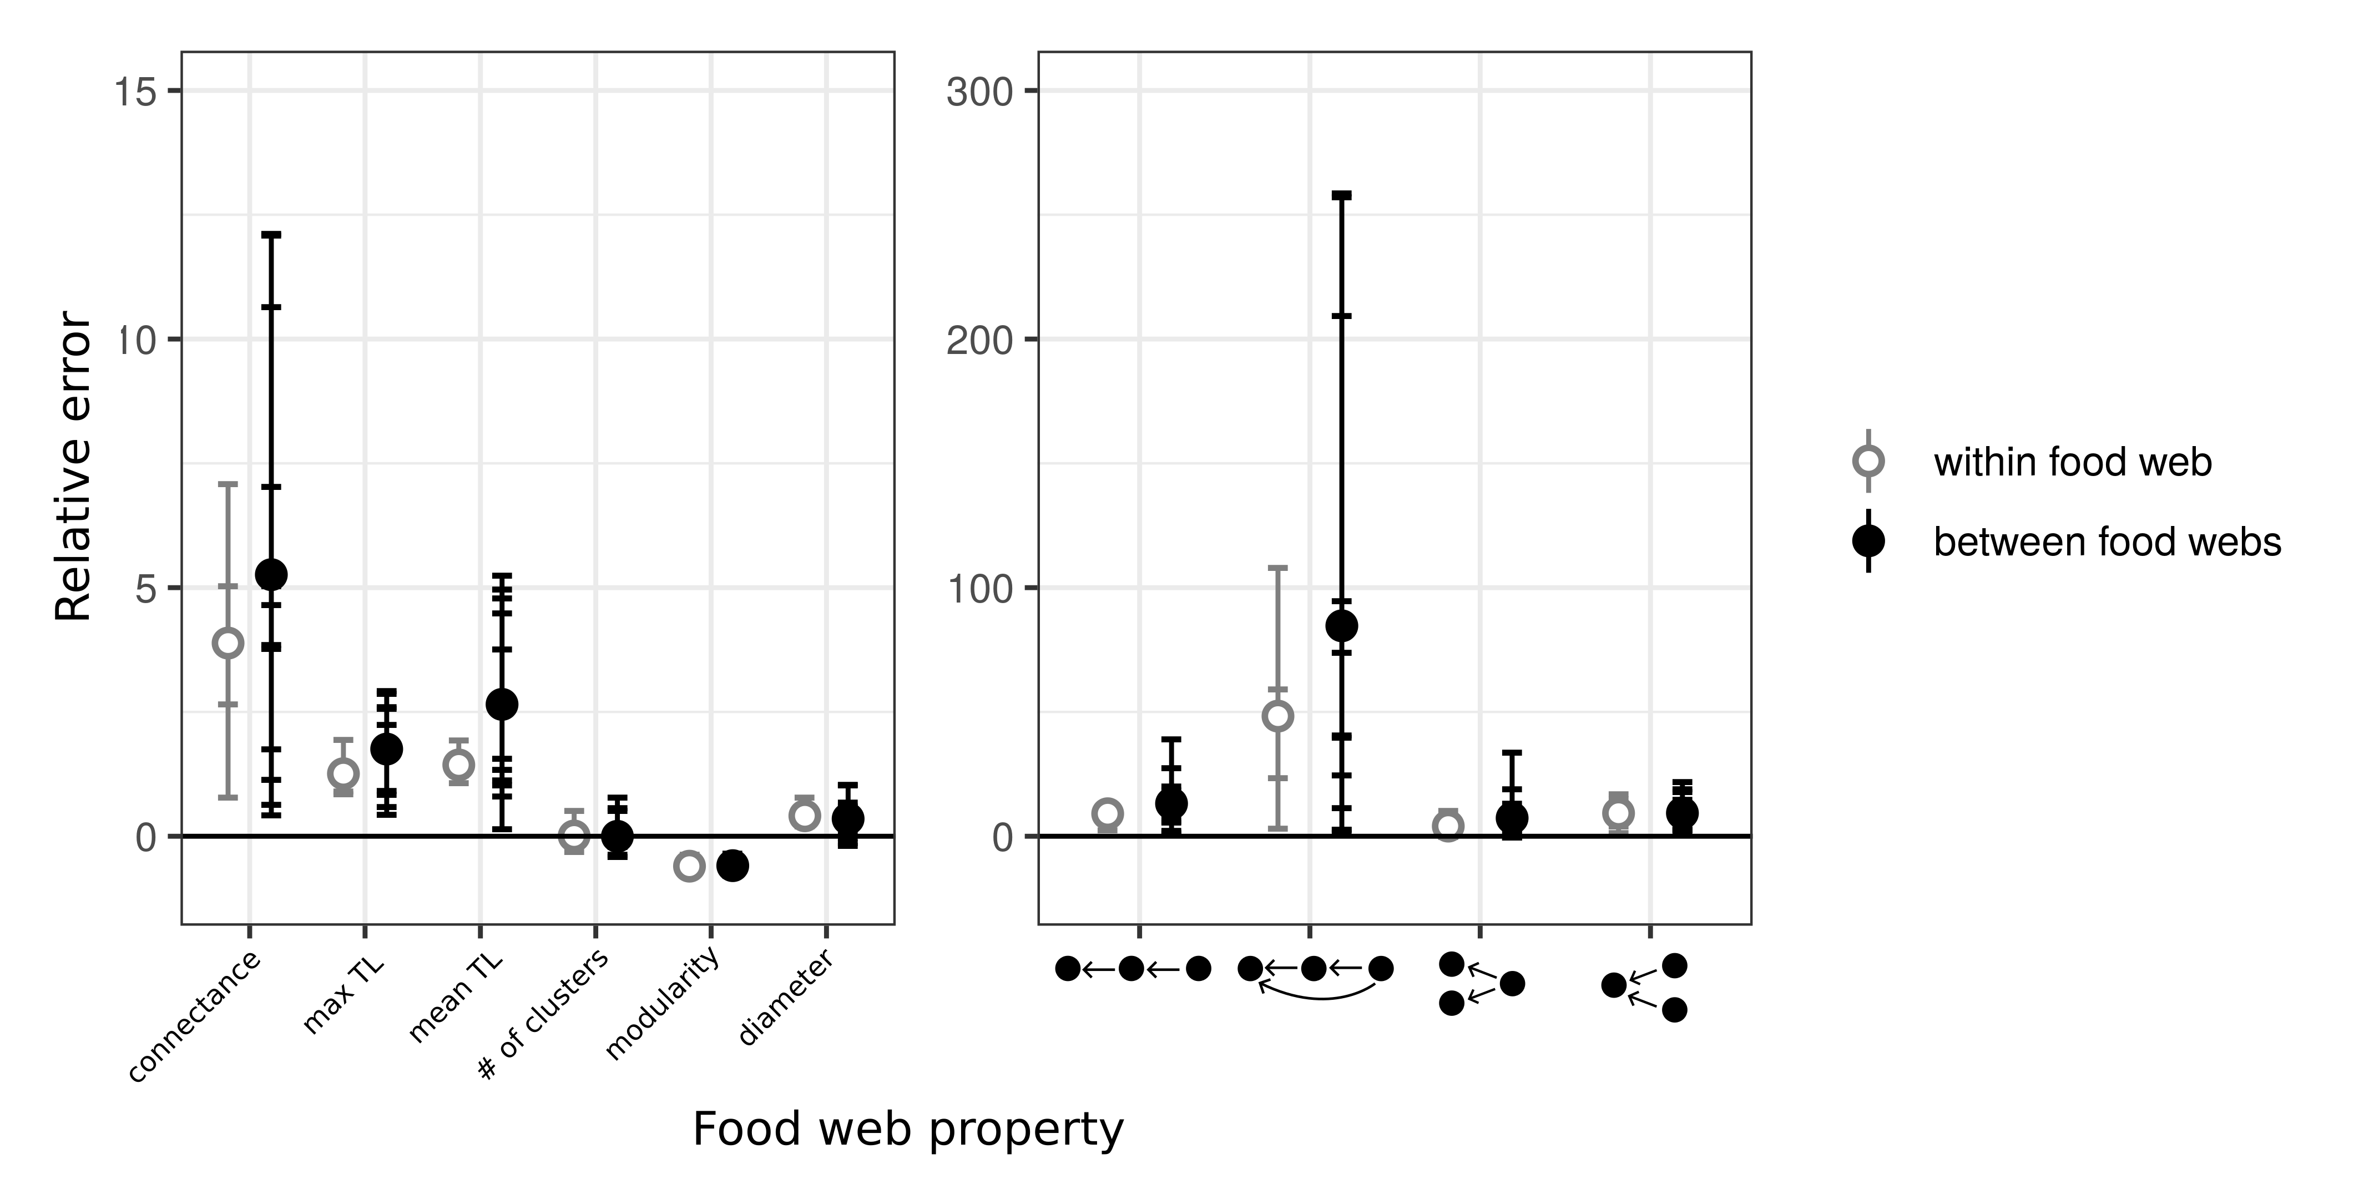  
Figure 5: ***Prediction error of global food web properties****. Relative error is the difference between the predicted and the empirical estimates divided by the empirical estimate. From left to right, the figure shows the relative error for connectance, maximum trophic level, mean trophic level, number of clusters, modularity, diameter, number of linear chain (predator – consumer - resource), intraguild predation (omnivore – consumer - resource), direct competition (2 consumers – 1 resource), and apparent competition motifs . Short horizontal lines are the relative errors for each property, model, and food web predicted combination. Grey open dots are the mean relative errors for within food web predictions and full black dots are the mean relative errors for between food web predictions.*